NAME: P. Gunasri
REG.NO: 192324103
DATE :23/12/2025
DAY-5
21.Scenario:
you are a scientist conducting research on rare elements found in a specific region. Your goal is to
estimate the average concentration of a rare element in the region using a random sample of
measurements. You will use the NumPy library to perform point estimation and calculate
confidence intervals for the population mean.The rare element concentration data is stored in a CSV
file named "rare_elements.csv," where each row contains a single measurement of the
concentration.
Question:
write a Python program that allows the user to input the sample size, confidence level, and desired
level of precision.
CODE:
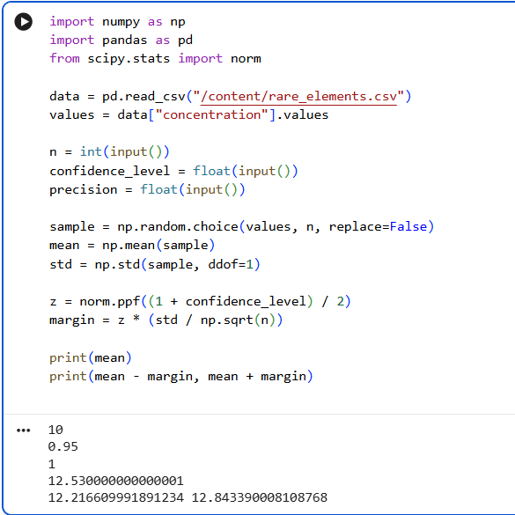
22.Scenario:
Imagine you are an analyst for a popular online shopping website. Your task is to analyze customer
reviews and provide insights on the average rating and customer satisfaction level for a specific
product category.
Question:
You will use the pandas library to calculate confidence intervals to estimate the true population
mean rating.
You have been provided with a CSV file named "customer_reviews.csv," which contains customer
ratings for products in the chosen category.
CODE:
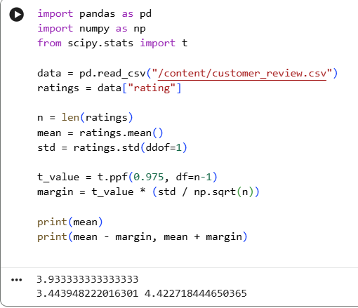
23.Scenario:
You are a researcher working in a medical lab, investigating the effectiveness of a new treatment
for a specific disease. You have collected data from a clinical trial with two groups: a control group
receiving a placebo, and a treatment group receiving the new drug.Your goal is to analyze the data
using hypothesis testing and calculate the p-value to determine if the new treatment has a
statistically significant effect compared to the placebo. You will use the matplotlib library to
visualize the data and the p-value.
CODE:
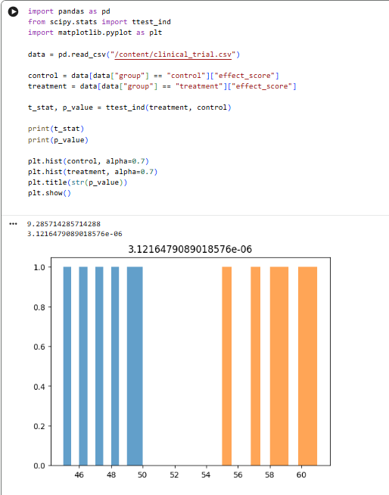
26.Question 3: Linear Regression for Housing Price Prediction
You are a real estate analyst trying to predict housing prices based on various features of the
houses, such as area, number of bedrooms, and location. You have collected a dataset of houses
with their respective prices.
Write a Python program that allows the user to input the features (area, number of bedrooms, etc.)
of a new house. The program should use linear regression from scikit-learn to predict the price of
the new house based on the input features.
CODE:
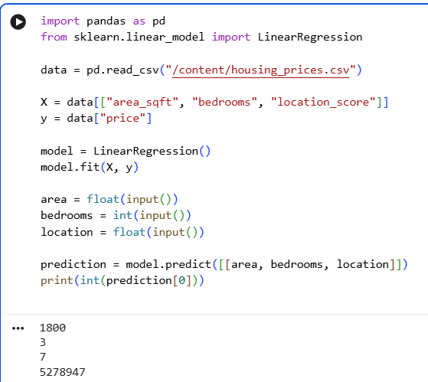
32. Scenario: You work as a data scientist for a real estate company. The company has collected
data on various houses, including features such as the size of the house, number of bedrooms,
location, and other relevant attributes. The marketing team wants to build a predictive model to
estimate the price of houses based on their features. They believe that linear regression modeling
can be an effective approach for this task.
Question: Your task is write a Python program to perform bivariate analysis and build a linear
regression model to predict house prices based on a selected feature (e.g., house size) from the
dataset. Additionally, you need to evaluate the model's performance to ensure its accuracy and
reliability.
CODE:
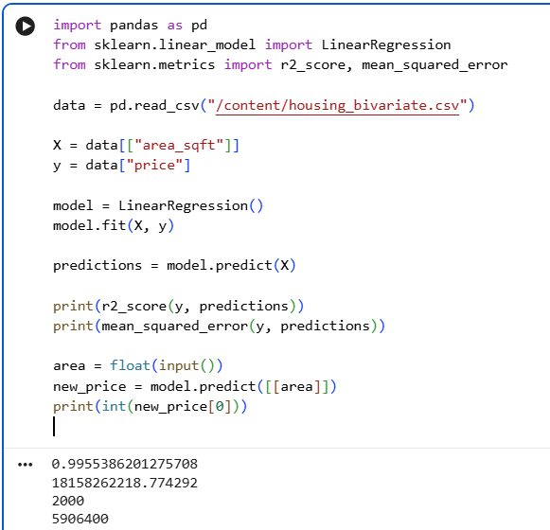
33. Scenario: You work as a data scientist for an automobile company that sells various car
models. The company has collected data on different car attributes, such as engine size,
horsepower, fuel efficiency, and more, along with their corresponding prices. The marketing team
wants to build a predictive model to estimate the price of cars based on their features.
Question: Your task is write a Python program that perform linear regression modeling to predict
car prices based on a selected set of features from the dataset. Additionally, you need to evaluate
the model's performance and provide insights to the marketing team to understand the most
influential factors affecting car prices.
CODE:
